**Challenge p**

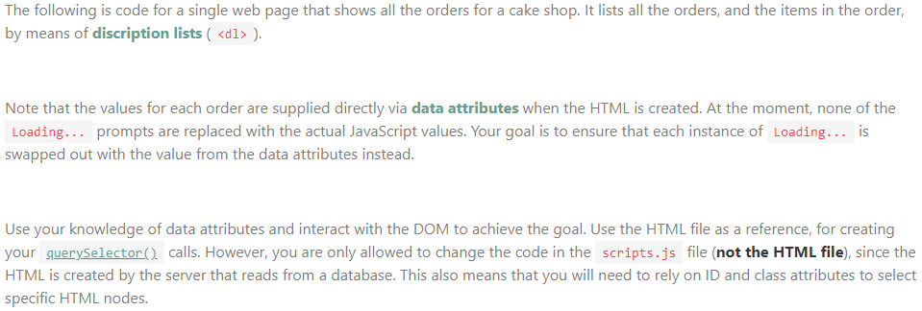

<!-- index.html -->

<!DOCTYPE html>

<html lang="en">

<head>

<meta charset="UTF-8">

<meta http-equiv="X-UA-Compatible" content="IE=edge">

<meta name="viewport" content="width=device-width, initial-scale=1.0">

<title>The JS Bakery</title>

<script src="./script.js" defer></script>

</head>

<body>

<h1>The JS Bakery</h1>

<h2>Orders</h2>

<section>

<h3>Order 1</h3>

<dl

data-key="order1"

data-biscuits="10"

data-donuts="13"

data-pancakes="0"

data-delivered="false"

>

<div class="biscuits">

<dt>Biscuits</dt>

<dd class="count">Loading...</dd>

</div>

<div class="donuts">

<dt>Donuts</dt>

<dd class="count">Loading...</dd>

</div>

<div class="pancakes">

<dt>Pancakes</dt>

<dd class="count">Loading...</dd>

</div>

<div class="status">

<dt>Status</dt>

<dd>Loading...</dd>

</div>

</dl>

</section>

<section>

<h3>Order 2</h3>

<dl

data-key="order2"

data-biscuits="5"

data-donuts="0"

data-pancakes="2"

data-delivered="false"

>

<div class="biscuits">

<dt>Biscuits</dt>

<dd class="count">Loading...</dd>

</div>

<div class="donuts">

<dt>Donuts</dt>

<dd class="count">Loading...</dd>

</div>

<div class="pancakes">

<dt>Pancakes</dt>

<dd class="count">Loading...</dd>

</div>

<div class="status">

<dt>Status</dt>

<dd>Loading...</dd>

</div>

</dl>

</section>

<section>

<h3>Order 3</h3>

<dl

data-key="order3"

data-biscuits="12"

data-donuts="11"

data-pancakes="15"

data-delivered="true"

>

<div class="biscuits">

<dt>Biscuits</dt>

<dd class="count">Loading...</dd>

</div>

<div class="donuts">

<dt>Donuts</dt>

<dd class="count">Loading...</dd>

</div>

<div class="pancakes">

<dt>Pancakes</dt>

<dd class="count">Loading...</dd>

</div>

<div class="status">

<dt>Status</dt>

<dd>Loading...</dd>

</div>

</dl>

</section>

</body>

</html>

________________________________________________________________________________________  
  
// script.js

//Only change below JS, not the HTML

const 1-root = document(order1),

const 1-biscuits: document(biscuits),

const 1-donuts: document(donuts),

const 1-pancakes: document(pancakes),

const 1-status: document(status)

const 2-root = document(order2),

const 2-biscuits: document(biscuits),

const 2-donuts: document(donuts),

const 2-pancakes: document(pancakes),

const 2-status: document(status)

const 3-root = document(order3),

const 3-biscuits: document(biscuits),

const 3-donuts: document(donuts),

const 3-pancakes: document(pancakes),

const 3-status: document(status)

1-biscuits= 1-root.biscuits,

1-donuts = 1-root.donuts,

1-pancakes = 1-root.pancakes,

1-status = 1-root.status ? Delivered : Pending

2-biscuits= 2-root.biscuits,

2-donuts = 2-root.donuts,

2-pancakes = 2-root.pancakes,

2-status = 2-root.status ? Delivered : Pending

3-biscuits= 3-root.biscuits,

3-donuts = 3-root.donuts,

3-pancakes = 3-root.pancakes,

3-status = 3-root.status ? Delivered : Pending